Mayan Primary Sources

Name: __________________

Period: __________________

Date: __________________

**#1**

1. What elements of their dress and decoration serve to mark their high status?

2. What aspects of the physical appearance of this couple might represent ideal male and female characteristics in Maya culture? Pay attention to their hair, foreheads, and noses, as well as to the attitude suggested by their faces

3. What might you infer about the relationship of Shield Jaguar and Lady Xok from this carving? Notice the relatively equal size of the two figures and the gesture that Shield Jaguar makes with his left hand. Keep in mind that the carving comes from a temple in Yaxchilan dedicated to Lady Xok.

**#2**

1. What do the various postures of the captives suggest? Notice that a number of the captives have blood dripping from their fingers. What does this indicate? What might be happening to the prisoner at the far left?

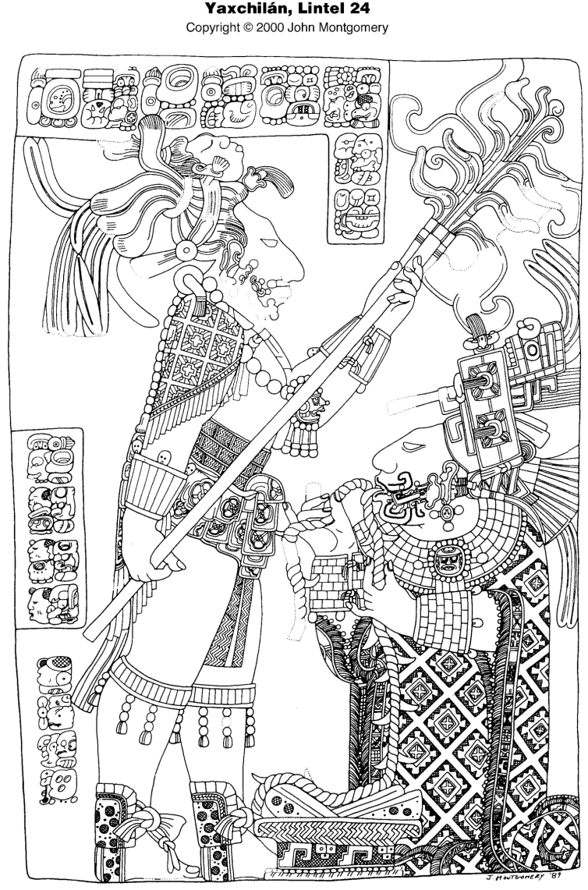

2. What status distinctions can you observe among the figures in the mural?

3. What meaning might you attach to the presence of the king's wife and mother at this event?

**#3**

1. What details can you notice in the exquisitely carved work?

2. What significance might you attribute to the fact that the couple is performing this ritual together?

3. Why do you think Lady Xok is kneeling?

4. Notice the shrunken head in Shield Jaguar's headdress. How would you assess its significance? How might it enhance his status?

5. To what extent is this pervasive bloodletting a uniquely Mesoamerican religious practice? What roles do blood and sacrifice play in other religious traditions?

Collapse – Audio Book

**\* 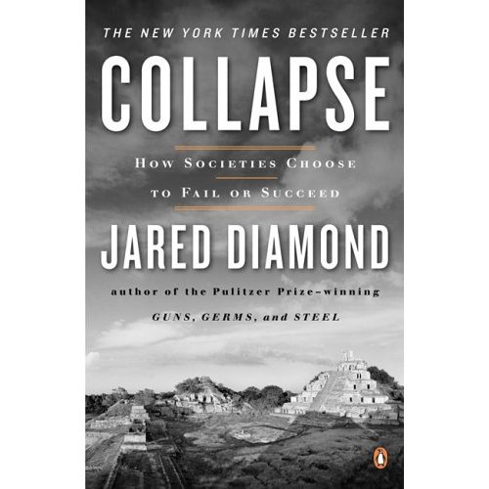Read “History and the Environment” – pg 182 first**

**Listen to the audio book on our site list the 5 point framework for studying societal collapse:**

1.

2.

3.

4.

5.

|  |
| --- |
| Discussion Points |
|  |
|  |
|  |
|  |
|  |
|  |
|  |

Aztec Video

|  |
| --- |
| Discussion Points |
|  |
|  |
|  |
|  |
|  |
|  |
|  |

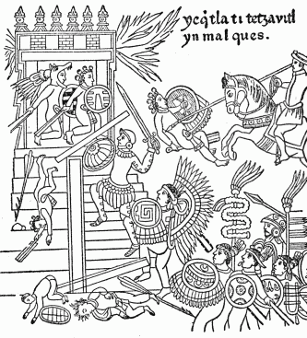

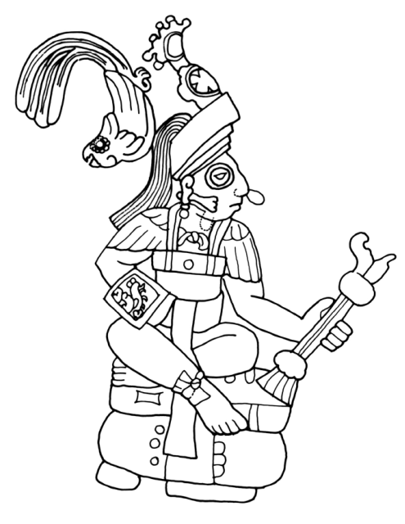

**Yax K'uk' Mo**